By Amrutiya Zeel(19IT003)

Department of information technology

Chandubhai S. patel institute of technology

Changa, Anand, Gujarat 388450, India.

* **Abstract**

We made a small application based on person’s requirement and remember the slogan of each and every people “Make India Digital” so if we think for the digitalization so we have to make each and every small and big thing digitalized so if every person thinks that and gave their efforts and hard works in particular field then we definitely achieve our Aim. So we make a one digitalized online Application that is E-Health Card. This application is very useful in medical life.

This is digitalized application so there is little bit difficulty in starting but after that it is very much useful for storing purpose and for privacy.

How e health card works in which platform we can make this application which tools we have to use which functions we have to use, that all described below.

In this we use java platform swing class, one class, JFrame class, constructor, inbuild functions, user defined functions, file handling like, switch case, Abstract Window Toolkit(AWT) concepts, variables, main method , if else statements ,scanner class , try catch block JFrame components like button , label ,text field , Jpassword field.

* **Intorduction to our project**

We made a small application based on person’s requirement and remember the slogan of each and every people “Make India Digital” so if we think for the digitalization so we have to make each and every small and big thing digitalized so if every person thinks that and gave their efforts and hard works in particular field then we definitely achieve our Aim. So we make a one digitalized online Application that is E-Health Card. This application is very useful in medical life.

What is E-Health card?

A Health Card is like an identity card, which identifies you as the person who has been insured by your health insurance company. Your health card provides you access to the network hospitals and your selected doctors for your treatment. The benefit of holding a health card is that it allows you to avail cashless treatment in network hospitals.

In our project we exactly worked on the digital system. So it reduces the book/pen work and gives you to work on digital process.

Because till now peoples of medical staff use pen /paper work and they keep records in that also.but due to these online digitalized facilities this will reduce the work of odd technique.

Yeah, this is new for uneducated people and even some peoples are also unaware about it. but we have to publicity the peoples about the digitalization and importance of health card.

How E-Health card works?

The E-Health Card is a digital tool embedded in a smartphone or tablet to assist providers during the care process. It works on the specified no. given by government to the users and according to that, number is given by admin or person who is accessing your Health Card system to login into your system and after once login he/she can check your details.

Comparison between E-health card with non E-health card system (no e- health card was there)

When there is no E-Health card facility available at that time the patients have to faces many problems.

At that time if patient had an appointment with doctor than he/she has to take the appointment before 1-2 days and confirmed it.

And now due to this system just patient had to check his/her card for next appointment.

When there is no e-health card facility available, that time patient has to keep his/her records given by doctor in file, if that file is missing or he/she don’t know where he/she kept that file than again he/she had to describe his/her problem to doctor.

With the use of this card the records are saved in the card, so if the file is missing then also you know the prescription from your card and many more details you can know from this card.

* **Literature Survey**

We go to the you tube, google, websites to search for the survey of E- health Card application but we didn’t get anything more importance regarding this application. Because there are plenty of computer engineers who make this kind of applications but then also some have completed their work some are still adding more features and make more innovative.so we didn’t get what we expect from the survey. Yeah Indian government also made this application and there are also some engineers still working on this and get the plenty of new features in future.

* **Which types of features you include in your project**

We basically choose java for to make this small application. because java is platform independence language so we can run java code at any platform as long as the computer has a java runtime environment(JRE) and java includes more features and it has it’s own libraries therefore java is more stable and predictable.

Yet we didn’t complete our whole project but we make a rough flow chart of project.

In this we use many combine concepts which java provides. firstly, we make one class which has its own constructor and class also have one main method which make class object and object calls some functions of swing class and class extends JFrame class in which java libraries provide many inbuild functions like button, textfield, textarea, radiobutton, label, choice and many more.

Then we defined object of that functions and this all have its own class. after doing that we make some functions which is used for exit from the program and display the current time. after that we create a string variable which takes the input from the scanner using scanner class. After that the class object calls the one function.

In the starting of that function we use some printout statement to print a label type e health card and after that some statements like

1. *>> Add New Patient Record*
2. *>> Add Diagnosis Information*

*3 >> History of the Patient   
4 >> Bill of the patient   
5 >> Exit*

Now using switch case one can enter the entry of which he/she has to show the information or data.

If the programmer wants to add new patient record the then programmer press the 1 after the he/she has to enter the details of the patients .he/she had to write the patient file name after that he/she had to fill the patient details in the file .so we also created a file class object for writing, appending data ,reading purpose.

For ex:- name ,id ,contact no, sex, age , type , bg , sex , disease , flag ,dadm etc.

After fill the patients details the data stored in the file.

If any one wants to add new diagnosis information then again, he/she has to open the patient file in which he/she had the stored the data in that the file is opened for the appending purpose. in this the we had asked for the symptoms, diagnosis, admission, medicine, ward no, doctor etc.

Again the data is added in the file and it stored it successfully.

If the programmer or user wants to check the history of the patient then he/she has to press 3. So it gets the history

And for 4 he/she gets the bill of the patient by including few variables like no of days patient stayed in hospital, charge, ward, doctor charge, ser.

And last but not least by pressing 5 one can exit from the program and again the below chart comes.

1. *>> Add New Patient Record*
2. *>> Add Diagnosis Information*

*3 >> History of the Patient   
4 >> Bill of the patient   
5 >> Exit .*

And if you move ahead in project then we called some functions like doctor, see doctor, patient, admin.

In this the admin is like the handler.

In e-health card the responsibility goes to the admin to keep the data safe and secure .and the conversation between patient and selected doctors and based on that the doctor gave the prescription to the patients.

So the work of admin person is to login and handle’s the data, also he/she has to keep that data file secure and privacy. The patients firstly had to keep contact with admin after that he/she give the appointment to the patient’s selected doctor. After that doctor check the patients file and, according to that doctor do the treatment of patient and give him/her to prescription.

In that we reached to doctor() then we asked for the doctor’s file name and information of the doctor like

name, id, contact no, sex, age, type, bg, sex, disease, flag, dadm etc.

and then it stored in the file.

See doctor () works like in that if we want to see doctors’ details. we also provided add new doctor, see patient details, see doctor details using switch case.

We also used the concepts of GUI and we make one action listener function which will work to see the output on the j panel screen rather than console screen.

in that action listener we compare password and user name of admin if it matches than and then only one can see the E-Health Card project. We also used files, try catch block in this function.

* **From where you got reference**

Yeah basically we want to make something useful and precious project which is totally different so we think regarding the sgp project what to make, how to implement all that.

Then we got the idea related hospital and then we search in google and you tube related to hospital projects and in that we got hospital management system after that we didn’t like hospital management project so we think more and then finally we got the idea of E-Health Card application. So after the stuff we finally decided to make this digitalized application. After that we watched videos, we read from website which tool is used in e health card which functions used in this etc all that and after that we implement in our application.

* **Conclusion**

By using this application, we get the following benefits

Smart health cards help you to get access to your healthcare benefits conveniently, protect your privacy and security and help control costs of providing healthcare by reducing administration and fraud.

When you have to use your e healthcare benefits, your e health card identifies you accurately and replaces form filling with more automated process.

Your prescription can be stored right on the card, so if you need it with you all the time.

Pin entry, healthcare professional cards and online access security all help to protect your privacy and healthcare information.

Overall healthcare costs are reduced by more effective administration, reduction of error and reduction of fraudulent by the use of this system benefits.

By this one gets benefit and knowledge of digitalized and by using online is easier than normal way. We didn’t keep the things in our mind like which medicine has doctor provided, how many tablets are there, cost of tablet, total doctor’s fee, hospital charge, any additional charge, and our store our medical data in file. This all are stored in our health card. So as a student, the digital system will work a lot and it reduced your complexity and make people aware about each and every thing.

**Report**

# Turnitin Originality Report

Processed on: 31-Oct-2020 14:18 IST Similarity Index **Similarity by Source**

ID: 1432072431 **12%** Internet Sources: 10%Publications: 1%

Word Count: 1898 Student Papers: 2%

Submitted: 1

5% match (Internet from 08-Mar-2016) [http://v2.web1-new.justaskgemalto.typhon.net/en/health/tips/what-are-mainadvantages-using-smart-health-card?page=0%2C1](http://v2.web1-new.justaskgemalto.typhon.net/en/health/tips/what-are-main-advantages-using-smart-health-card?page=0%2C1)

2% match (Internet from 30-Mar-2014) <http://insurance.royalsundaram.in/>

2% match (student papers from 03-Dec-2019)

Submitted to Military Technological College on 2019-12-03

1% match (Internet from 10-Aug-2019) [https://globalhealthleaders.org/the-first-e-health-card-launched-in-india-to-controlncds/](https://globalhealthleaders.org/the-first-e-health-card-launched-in-india-to-control-ncds/)

1% match (Internet from 18-Oct-2018) [https://www.royalsundaram.in/blog/health-insurance/what-are-the-benefit-ofholding-a-health-card/comment-page-1/](https://www.royalsundaram.in/blog/health-insurance/what-are-the-benefit-of-holding-a-health-card/comment-page-1/)

1% match (Internet from 18-Jun-2017)

<http://www.i-scholar.in/index.php/indjst/article/download/131174/119536>

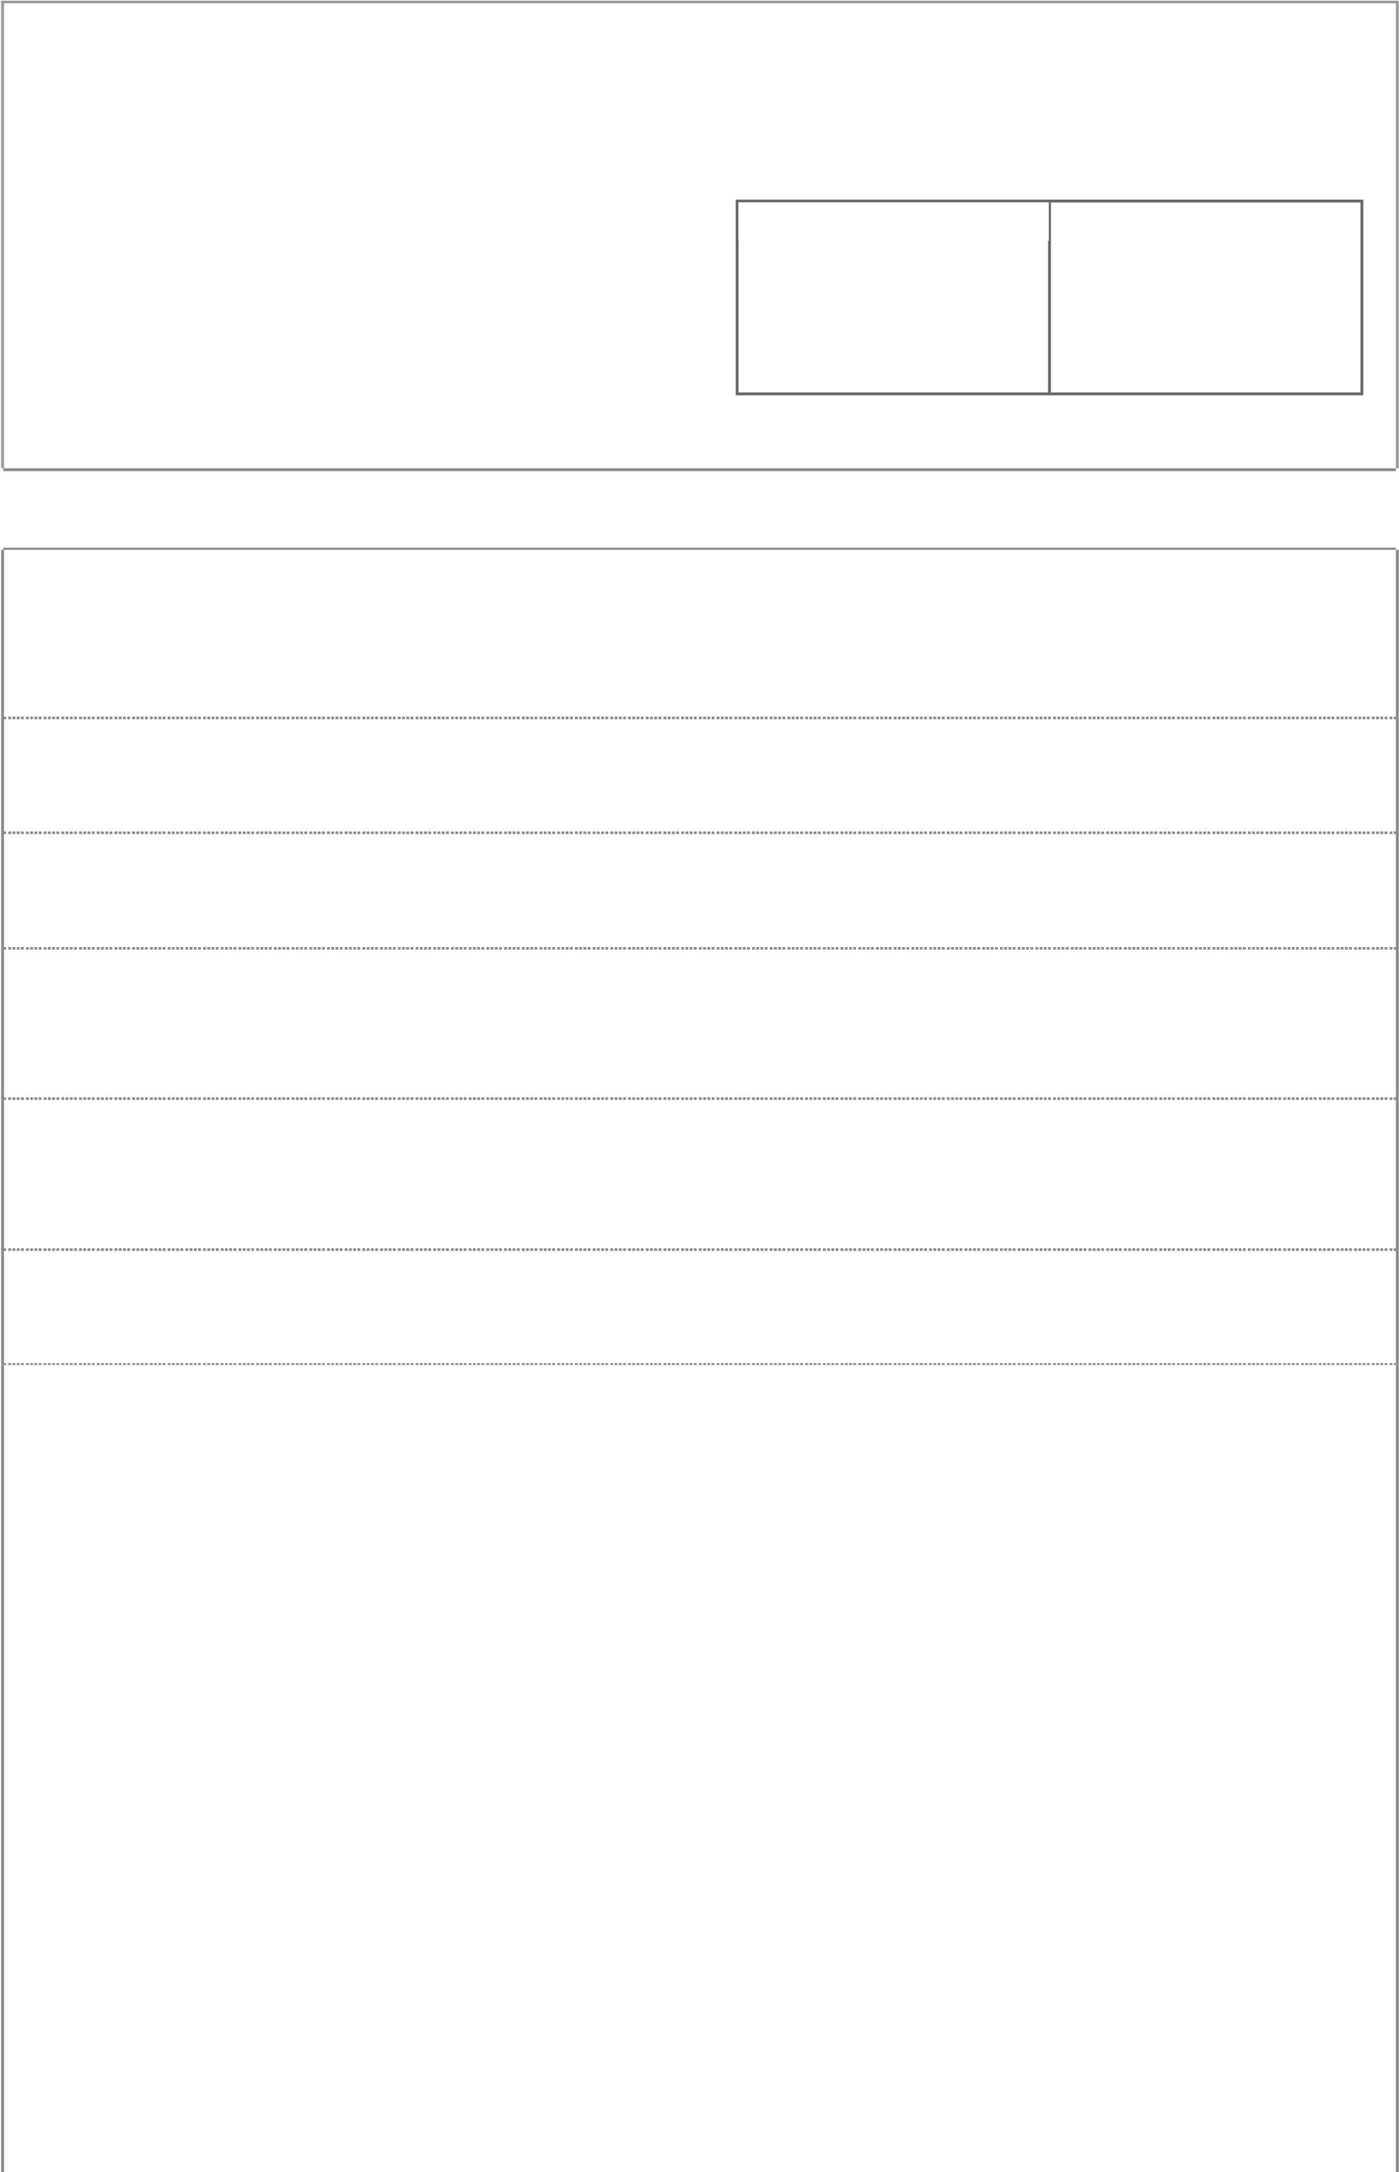By Amrutiya Zeel(19IT003), Chandravadia Vipul (19IT021) Department of information technology Chandubhai S. patel institute of technology Changa, Anand, Gujarat 388450, India. • Abstract We made a small application based on person’s requirement and remember the slogan of each and every people “Make India Digital” so if we think for the digitalization so we have to make each and every small and big thing digitalized so if every person thinks that and gave their efforts and hard works in particular field then we definitely achieve our Aim. So we make a one digitalized online Application that is EHealth Card. This application is very useful in medical life. This is digitalized application so there is little bit difficulty in starting but after that it is very much useful for storing purpose and for privacy. How e health card works in which platform we can make this application which tools we have to use which functions we have to use, that all described below. In this we use java platform swing class, one class, JFrame class, constructor, inbuild functions, user defined functions, file handling like, switch case, Abstract Window Toolkit(AWT) concepts, variables, main method , if else statements ,scanner class , try catch block JFrame components like button , label ,text field , Jpassword field. • Intorduction to our project We made a small application based on person’s requirement and remember the slogan of each and every people “Make India Digital” so if we think for the digitalization so we have to make each and every small and big thing digitalized so if every person thinks that and gave their efforts and hard works in particular field then we definitely achieve our Aim. So we make a one digitalized online Application that is E-Health Card. This application is very useful in medical life. What is E -Health card? A Health Card is like an identity card, which identifies you as the person who has been insured by your health insurance company. Your health card provides you access to the network hospitals and your selected doctors for your treatment. The benefit of holding a health card is that it allows you to avail cashless treatment in network hospitals. In our project we exactly worked on the digital system. So it reduces the book/pen work and gives you to work on digital process. Because till now peoples of medical staff use pen /paper work and they keep records in that also.but due to these online digitalized facilities this will reduce the work of odd technique. Yeah, this is new for uneducated people and even some peoples are also unaware about it. but we have to publicity the peoples about the digitalization and importance of health card. How E-Health card works? The E-Health Card is a digital tool embedded in a smartphone or tablet to assist providers during the care process. It works on the specified no. given by government to the users and according to that, number is given by admin or person who is accessing your Health Card system to login into your system and after once login he/she can check your details. Comparison between E-health card with non E-health card system (no e- health card was there) When there is no EHealth card facility available at that time the patients have to faces many problems. At that time if patient had an appointment with doctor than he/she has to take the appointment before 1-2 days and confirmed it. And now due to this system just patient had to check his/her card for next appointment. When there is no e-health card facility available, that time patient has to keep his/her records given by doctor in file, if that file is missing or he/she don’t know where he/she kept that file than again he/she had to describe his/her problem to doctor. With the use of this card the records are saved in the card, so if the file is missing then also you know the prescription from your card and many more details you can know from this card. • Literature Survey We go to the you tube, google, websites to search for the survey of E- health Card application but we didn’t get anything more importance regarding this application. Because there are plenty of computer engineers who make this kind of applications but then also some have completed their work some are still adding more features and make more innovative.so we didn’t get what we expect from the survey. Yeah Indian government also made this application and there are also some engineers still working on this and get the plenty of new features in future. • Which types of features you include in your project We basically choose java for to make this small application. because java is platform independence language so we can run java code at any platform as long as the computer has a java runtime environment(JRE) and java includes more features and it has it’s own libraries therefore java is more stable and predictable. Yet we didn’t complete our whole project but we make a rough flow chart of project. In this we use many combine concepts which java provides. firstly, we make one class which has its own constructor and class also have one main method which make class object and object calls some functions of swing class and class extends JFrame class in which java libraries provide many inbuild functions like button, textfield, textarea, radiobutton, label, choice and many more. Then we defined object of that functions and this all have its own class. after doing that we make some functions which is used for exit from the program and display the current time. after that we create a string variable which takes the input from the scanner using scanner class. After that the class object calls the one function. In the starting of that function we use some printout statement to print a

label type e health card and after that some statements like 1 >> Add New Patient Record 2 >> Add Diagnosis Information 3 >> History of the Patient 4 >> Bill of the patient 5 >> Exit Now using switch case one can enter the entry of which he/she has to show the information or data. If the programmer wants to add new patient record the then programmer press the 1 after the he/she has to enter the details of the patients .he/she had to write the patient file name after that he/she had to fill the patient details in the file .so we also created a file class object for writing, appending data ,reading purpose. For ex:- name ,id ,contact no, sex, age , type , bg , sex , disease , flag ,dadm etc. After fill the patients details the data stored in the file. If any one wants to add new diagnosis information then again, he/she has to open the patient file in which he/she had the stored the data in that the file is opened for the appending purpose. in this the we had asked for the symptoms, diagnosis, admission, medicine, ward no, doctor etc. Again the data is added in the file and it stored it successfully. If the programmer or user wants to check the history of the patient then he/she has to press 3. So it gets the history And for 4 he/she gets the bill of the patient by including few variables like no of days patient stayed in hospital, charge, ward, doctor charge, ser. And last but not least by pressing 5 one can exit from the program and again the below chart comes. 1 >> Add New Patient Record 2 >> Add Diagnosis Information 3 >> History of the Patient 4>> Bill of the patient 5 >> Exit . And if you move ahead in project then we called some functions like doctor, see doctor, patient, admin. In this the admin is like the handler. In e-health card the responsibility goes to the admin to keep the data safe and secure .and the conversation between patient and selected doctors and based on that the doctor gave the prescription to the patients. So the work of admin person is to login and handle’s the data, also he/she has to keep that data file secure and privacy. The patients firstly had to keep contact with admin after that he/she give the appointment to the patient’s selected doctor. After that doctor check the patients file and, according to that doctor do the treatment of patient and give him/her to prescription. In that we reached to doctor() then we asked for the doctor’s file name and information of the doctor like name, id, contact no, sex, age, type, bg, sex, disease, flag, dadm etc. and then it stored in the file. See doctor () works like in that if we want to see doctors’ details. we also provided add new doctor, see patient details, see doctor details using switch case. We also used the concepts of GUI and we make one action listener function which will work to see the output on the j panel screen rather than console screen. in that action listener we compare password and user name of admin if it matches than and then only one can see the E-Health Card project. We also used files, try catch block in this function. • From where you got reference Yeah basically we want to make something useful and precious project which is totally different so we think regarding the sgp project what to make, how to implement all that. Then we got the idea related hospital and then we search in google and you tube related to hospital projects and in that we got hospital management system after that we didn’t like hospital management project so we think more and then finally we got the idea of E-Health Card application. So after the stuff we finally decided to make this digitalized application. After that we watched videos, we read from website which tool is used in e health card which functions used in this etc all that and after that we implement in our application. • Conclusion By using this application, we get the following benefits Smart health cards help you to get access to your healthcare benefits conveniently, protect your privacy and security and help control costs of providing healthcare by reducing administration and fraud. When you have to use your e healthcare benefits, your e health card identifies you accurately

and replaces form filling with more automated process. Your prescription can be stored right on the card, so if you need it with you all the time. Pin entry,

|  |
| --- |
| healthcare professional cards and online access security all help to protect your privacy and healthcare information. Overall healthcare costs are reduced by more effective administration, reduction of error and reduction of fraudulent by the use of this system benefits. By this one gets benefit and knowledge of digitalized and by using online is easier than normal way. We didn’t keep the things in our mind like which medicine has doctor provided, how many tablets are there, cost of tablet, total doctor’s fee, hospital charge, any additional charge, and our store our medical data in file. This all are stored in our health card. So as a student, the digital system will work a lot and it reduced your complexity and make people aware about each and every thing. |